



Implementation of Factorial Calculation and Fibonacci Sequence using python recursion function
LAB MANUAL

Disclaimer: The content is curated from online/offline resources and used for educational purpose only
Implementation of Factorial Calculation and Fibonacci Sequence using python recursion function

Objective:
- Implement a recursive function that calculates the factorial of a given non-negative integer n.
- Implement a recursive function that calculates the nth Fibonacci number
Problem Statement:
- Recursion is a powerful concept in Python, where a function calls itself to solve smaller instances of a problem. This problem focuses on implementing recursion for two common mathematical problems: calculating the factorial of a number and generating the Fibonacci sequence. Both tasks can be solved using recursive functions, allowing for an elegant and efficient solution.
Equipment Required:
- Install VS Code - https://code.visualstudio.com/download
- Download Python Installer File - https://www.python.org/downloads/
Prerequisites:
- Basic Computer Skills - Anyone starting to learn computer programming needs basic computer skills.
- Basics of control statements

Procedure:
Task 1: Implement a recursive function that calculates the factorial of a given non-negative integer n.
Task 2: Implement a recursive function that calculates the nth Fibonacci number

Task 1: Implement a recursive function that calculates the factorial of a given non-negative integer n.
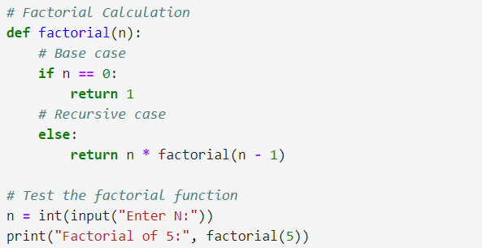

Output:
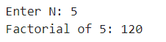
#

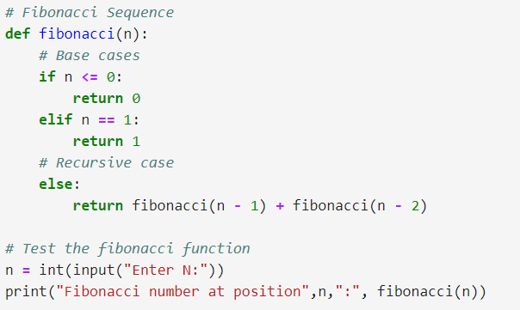
Output:
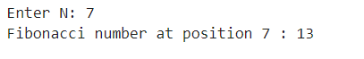

Both task1 & 2 are highlight the importance of recursion and its practical use in mathematical problems.

